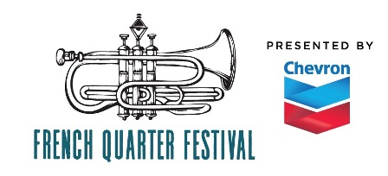
French Quarter Festivals, Inc.
Call for: Marketing Intern
for the 2020 French Quarter Festival presented by Chevron
Start date: January 2020
Respond to: Rebecca Sell, Marketing Director (504) 227-3119 or rebecca@fqfi.org

This is a non-paid internship but is an invaluable learning opportunity for someone interested in gaining experience in non-profit, event marketing, public relations, direct marketing, and/or project management. Flexibility, willingness to take on any task, ask questions, and be a team player is of upmost importance.
PRE-FESTIVAL: Weekly office hours are flexible.
- Database management: enter complete music schedule for publication on website, app, and brochure
- Research: create and/or update artist bios
- Serve as a festival representative at press conferences
- Assist in editing official festival brochure and press releases
- Create press kits and media credentials
- Assist with media production schedule
- Community outreach and brochure distribution
- Deliver promotional materials to media partners

DURING FESTIVAL: April 16-19, 2020 – Must be available all day each day of event
- Manage media center
- Support social media team
- Hang signage
- Serve as production assistant for media broadcasts

LOAD OUT: (if available)
- Assist in removing signage, equipment, supplies from festival sites back FQFI offices

