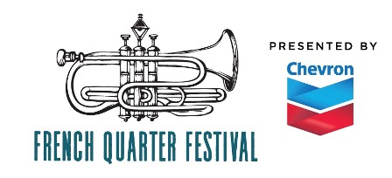
French Quarter Festivals, Inc.

Call for: FQFI Entertainment Manager Intern for the 2020 French Quarter Festival presented by Chevron
Start date: January, 2020
Respond to: Greg Schatz, FQFI Entertainment and Production Director, 504-227-3121, greg@fqfi.org

This is a non-paid internship but is an invaluable learning opportunity for someone interested to gain experience in large-scale live event production in high paced environments. Willingness to take on any task, ask questions, and be a team player is of upmost importance.

French Quarter Festival is the largest free festival in the South and 23 stages of live music in 2019. Intern would assist the Entertainment Manager with many aspects of entertainment production, including:

PRE-FESTIVAL: Weekly office hours are flexible.
- Create spreadsheets, files, bins, make directions and maps. etc..
• Update and review musician contracts.
• Advance technical needs with over 260 musical groups.
• Creating production binder books for production crew, stage managers, musician parking staff and sound companies.
• Help organize and implement musician parking program.
• Mail various credential placards.
• Logistical planning for the musicians and crew.
LOAD-IN:
- Assist in set up of festival including, stage and backstage areas, placing signage,
- Make sure sound companies have everything they need to have stages ready.

DURING FESTIVAL: April 16-19, 2020 (Long daily hours)
Intern would work as a production assistant during the entire 4 days of French Quarter Festival.
- Coordinate with entertainment manager and other productions assistants to solve problems and complete production tasks.
- Coordinate with musician parking lot personnel.
- Help musicians with transportation issues.
- Work as needed to ensure festival success.

LOAD OUT/WRAP UP: (if available) signage, equipment, supplies from festival sites back FQFI offices .
- Completing paperwork.
- Organizing and inventory of production gear.
- Debrief about the festival.

